Java Program to add two matrices

We can add two matrices in java using binary + operator. A matrix is also known as array of arrays.

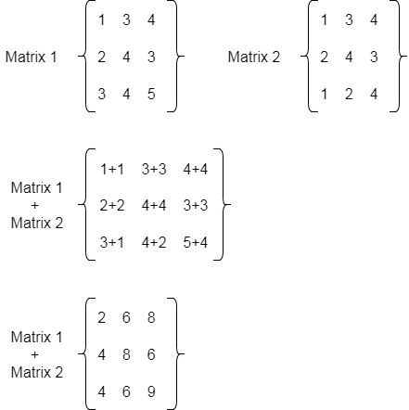

To subtract two matrices, use - operator. Let's see a simple example to add two matrices of 3 rows and 3 columns.

**public** **class** MatrixAdditionExample

{

**public** **static** **void** main(String args[])

{

//creating two matrices

**int** a[][]={{1,3,4},{2,4,3},{3,4,5}};

**int** b[][]={{1,3,4},{2,4,3},{1,2,4}};

//creating another matrix to store the sum of two matrices

**int** c[][]=**new** **int**[3][3];  //3 rows and 3 columns

//adding and printing addition of 2 matrices

**for**(**int** i=0;i<3;i++){

**for**(**int** j=0;j<3;j++){

c[i][j]=a[i][j]+b[i][j];    //use - for subtraction

System.out.print(c[i][j]+" ");

}

System.out.println();//new line

}

}

}

2 6 8

4 8 6

4 6 9

Method 2:

import java.util.Scanner;

class AddMatrix

{

public static void main(String args[])

{

int row, col,i,j;

Scanner in = new Scanner(System.in);

System.out.println("Enter the number of rows");

row = in.nextInt();

System.out.println("Enter the number columns");

col = in.nextInt();

int mat1[][] = new int[row][col];

int mat2[][] = new int[row][col];

int res[][] = new int[row][col];

System.out.println("Enter the elements of matrix1");

for ( i= 0 ; i < row ; i++ )

{

for ( j= 0 ; j < col ;j++ )

mat1[i][j] = in.nextInt();

System.out.println();

}

System.out.println("Enter the elements of matrix2");

for ( i= 0 ; i < row ; i++ )

{

for ( j= 0 ; j < col ;j++ )

mat2[i][j] = in.nextInt();

System.out.println();

}

for ( i= 0 ; i < row ; i++ )

for ( j= 0 ; j < col ;j++ )

res[i][j] = mat1[i][j] + mat2[i][j] ;

System.out.println("Sum of matrices:-");

for ( i= 0 ; i < row ; i++ )

{

for ( j= 0 ; j < col ;j++ )

System.out.print(res[i][j]+"\t");

System.out.println();

}

}

}

Output:

Enter the number of rows

2

Enter the number columns

2

Enter the elements of matrix1

1 1

1 1

Enter the elements of matrix2

2 2

2 2

Sum of matrices:-

3 3

3 3